**Kol Simcha Torah Gazette**

**For parsha chukas 5785**

Volume 9 Issue 40 (Whole #455) 9 Tammuz 5785/ July 5, 2025

**Printed L’illuy nishmas Nechama bas R’ Noach, a”h**

For a free subscription, please forward your request to [***keren18@juno.com***](mailto:keren18@juno.com)

***Past emails can be found on the website ShabbosStories.com under Brooklyn Torah Gazette***

**What Is the “Book of**

**the Wars of G-d”?**

**By**[**Mordechai Rubin**](https://www.chabad.org/search/keyword_cdo/kid/21532/jewish/Rubin-Mordechai.htm)

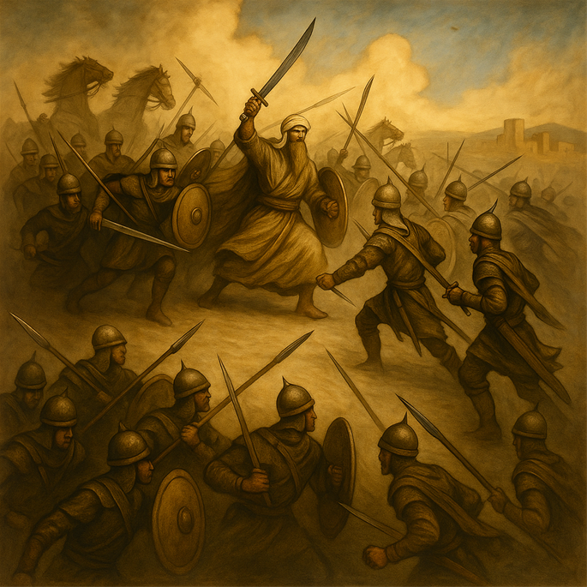

Toward the end of Parshat Chukat, the Torah quotes a mysterious source. In Numbers, chapter 21, the narrative describes the Israelites’ travels: after leaving the Zered valley, they camp “on the other side of the Arnon” – a river marking the border between Moab and the Amorites.[1](javascript:doFootnote('1a6940810');) The text then states:

Concerning this, it is told in the Books of the Wars of the L-rd, “[from] Vahev in Sufah, and the valleys of Arnon. And the spilling of the streams that turned to settle at Ar and leaned toward the border of [Moab](https://www.chabad.org/library/article_cdo/aid/756620/jewish/Why-are-Ammonite-and-Moabite-men-punished.htm).”[2](javascript:doFootnote('2a6940810');)

Leaving aside the obscure nature of these verses, the most obvious question that jumps off the pages is: What is the “Book of the Wars of the L-rd”? Is it perhaps an ancient book that we’ve since lost? Below, we will examine the approaches of several commentators.

**1. Not An Actual Book**

Rashi and his grandson, Rashbam, explain that the word we typically translate as “book,” ספר, here means “story” or “account.” In his view, the verse isn’t citing an actual lost volume, but saying that when people retell the stories of G‑d’s miraculous battles on Israel’s behalf, this event at Arnon will be included among them, just like the Splitting of the Sea.

**2. A Lost Historical Book of Wars**

Conversely, Ibn Ezra writes that there was indeed an actual book by this title, now long lost, in which “the wars of the L-rd” were written down for posterity. He even speculates that its origins might date back to the time of Abraham. He notes that many writings from biblical times have been lost (citing examples like Divrei Natan and others mentioned in Tanakh[3](javascript:doFootnote('3a6940810');)), and The Book of the Wars of [G‑d](https://www.chabad.org/library/article_cdo/aid/433240/jewish/God.htm) was likely one of those lost sources.[4](javascript:doFootnote('4a6940810');)

Nachmanides further elaborates on how such a book came to be. He explains that in each generation, there were wise men or bards – whom [Nachmanides](https://www.chabad.org/library/article_cdo/aid/111857/jewish/Ramban.htm) calls “*moshlim*” (poets) – who recorded the great battles and victories of their times, often in poetic form. The [Torah](https://www.chabad.org/library/article_cdo/aid/1426382/jewish/Torah.htm), he says, is quoting a snippet from one such book. [5](javascript:doFootnote('5a6940810');)

**3. A Record of Borders and Forbidden Lands**

Chizkuni writes that the Israelites kept a book in which they recorded the borders of lands they passed. This log included entries such as this cryptic line, which is essentially a list of locations. According to this, the book served as a geographic and halachic record of their journey, particularly noting where they were forbidden to wage war, referencing the warnings against waging war against Edom, Moab, and Ammon found in Deuteronomy Chapter 2.[6](javascript:doFootnote('6a6940810');)

**4. Exodus or**[**Deuteronomy**](https://www.chabad.org/library/bible_cdo/aid/8164/jewish/Devarim-Deuteronomy.htm)

The Targum Yerushalmi renders the Book of the Wars of the L-rd as “the Book of G‑d’s Torah.”[7](javascript:doFootnote('7a6940810');)

Which book?

The Midrash Aggadah singles out the Book of Exodus, which recounts G‑d’s war against Egypt and the Splitting of the Sea. It connects this to the verse in Exodus, “Until Your people cross, O L-rd…”[8](javascript:doFootnote('8a6940810');), and explains that this refers both to the crossing of the Arnon Valley and later the crossing of the Jordan. According to this view, the places mentioned in the verses above are all reflections of allusions found in the Song at the Sea, pointing to past and future miracles.[9](javascript:doFootnote('9a6940810');)

Rokeach writes that the Book of the Wars of G‑d is a reference to the Book of Deuteronomy, which records how G‑d gave mighty nations into the hands of the weak — for example, the Emim, who were defeated by the Moabites; the Refa’im, defeated by the Ammonites; and the battles against Sichon and Og. All of these victories were miraculous and thus worthy of being called “wars of the L-rd.”[10](javascript:doFootnote('10a6940810');)

**5. The Book Before G‑d**

Ohr Hachaim interprets the Book of the Wars of the L-rd as the heavenly record before G‑d. The verse is understood as follows:

In the book that is before G‑d, which concerns the wars and territorial inheritances of the nations. That divine book determines which nation will receive which land. And in that book, it is stated that in the future—at the end (*besofah*)—this very border will be given to Israel.”[11](javascript:doFootnote('11a6940810');)

**6. What Will Be Said in the Book**

Onkelos translates the verse to mean: “Therefore it will be said in the book – [about] the wars of Hashem…” In his reading, the Book of the Wars of G‑d is not the name of the book, but the subject of what will be said in the book. It will contain accounts of G‑d’s wars — but the title of the book itself is not given.[12](javascript:doFootnote('12a6940810');)

This is similar to the explanation of some later scholars who explain that the book was not yet written in the days of Moses. Rather, the Torah is stating that these events will be recorded in the future by the sages and chroniclers who would later write a history of G‑d’s wars.[13](javascript:doFootnote('13a6940810');)

**Footnotes**

[1.](https://www.chabad.org/parshah/article_cdo/aid/6940810/jewish/What-Is-the-Book-of-the-Wars-of-G-d.htm" \l "footnoteRef1a6940810) [Numbers, 21:10](https://www.chabad.org/9949#v10)–15. [2.](https://www.chabad.org/parshah/article_cdo/aid/6940810/jewish/What-Is-the-Book-of-the-Wars-of-G-d.htm#footnoteRef2a6940810) [Numbers, 21:14](https://www.chabad.org/9949#v14)-15. [3.](https://www.chabad.org/parshah/article_cdo/aid/6940810/jewish/What-Is-the-Book-of-the-Wars-of-G-d.htm#footnoteRef3a6940810) 2 [Chronicles 9:29](https://www.chabad.org/16529#v29)

[4.](https://www.chabad.org/parshah/article_cdo/aid/6940810/jewish/What-Is-the-Book-of-the-Wars-of-G-d.htm" \l "footnoteRef4a6940810) Ibn Ezra, [Numbers, 21:14](https://www.chabad.org/9949#v14). [5.](https://www.chabad.org/parshah/article_cdo/aid/6940810/jewish/What-Is-the-Book-of-the-Wars-of-G-d.htm#footnoteRef5a6940810) Nachmanides, [Numbers, 21:14](https://www.chabad.org/9949#v14).

[6.](https://www.chabad.org/parshah/article_cdo/aid/6940810/jewish/What-Is-the-Book-of-the-Wars-of-G-d.htm" \l "footnoteRef6a6940810) Chizkuni, [Numbers, 21:14](https://www.chabad.org/9949#v14). [7.](https://www.chabad.org/parshah/article_cdo/aid/6940810/jewish/What-Is-the-Book-of-the-Wars-of-G-d.htm#footnoteRef7a6940810) Targum Yerushalmi, [Numbers, 21:14](https://www.chabad.org/9949#v14).

[8.](https://www.chabad.org/parshah/article_cdo/aid/6940810/jewish/What-Is-the-Book-of-the-Wars-of-G-d.htm" \l "footnoteRef8a6940810) [Exodus 15:16](https://www.chabad.org/9876#v16). [9.](https://www.chabad.org/parshah/article_cdo/aid/6940810/jewish/What-Is-the-Book-of-the-Wars-of-G-d.htm#footnoteRef9a6940810) Midrash Aggadah, [Numbers, 21:14](https://www.chabad.org/9949#v14).

[10.](https://www.chabad.org/parshah/article_cdo/aid/6940810/jewish/What-Is-the-Book-of-the-Wars-of-G-d.htm" \l "footnoteRef10a6940810) Rokeach, [Numbers, 21:14](https://www.chabad.org/9949#v14). [11.](https://www.chabad.org/parshah/article_cdo/aid/6940810/jewish/What-Is-the-Book-of-the-Wars-of-G-d.htm#footnoteRef11a6940810) Ohr Hachaim, [Numbers, 21:14](https://www.chabad.org/9949#v14).

[12.](https://www.chabad.org/parshah/article_cdo/aid/6940810/jewish/What-Is-the-Book-of-the-Wars-of-G-d.htm" \l "footnoteRef12a6940810) Onkelos, [Numbers, 21:14](https://www.chabad.org/9949#v14). [13.](https://www.chabad.org/parshah/article_cdo/aid/6940810/jewish/What-Is-the-Book-of-the-Wars-of-G-d.htm#footnoteRef13a6940810) See Oznayim Latorah, [Numbers, 21:14](https://www.chabad.org/9949#v14).

Reprinted from the current website of Chabad.Org

**Rav Avigdor Miller on is the**

**Recent Rise in Anti-Semitism Something to Worry About?**

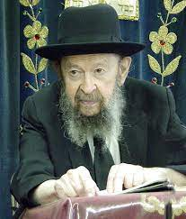

Absolutely! How could we not worry about it? But we have to know that there is a fundamental reason why it’s happening. It’s because Hashem is worried about us.– Yisroel has to turn away from Eisav (Bamidbar 20:21). We’re too much involved in gentile ideas, and it’s necessary to erect a wall. And that wall is anti-semitism. Always it happens, again and again in history – when Jews start getting lost among gentiles then it’s time for the gentiles to begin building a wall to prevent that.

And the first reaction to anti-semitism has to be not to contribute to the Simon Wiesenthal Center or other organizations that combat anti-semitism. No, no! In most cases those organizations cause anti-semitism. The way to combat anti-semitism is to build more yeshivos where children will be taken in for less schar limud; tuition should be made very low. The yeshivos should be so prosperous that they should be able to afford to take in children almost for nothing. That’s the ideal. And so, the Jewish child, sitting in the yeshiva, will be the one who is fighting against anti-semitism in the most efficient manner.

*Reprinted from a recent email of Toras Avigdor based on a Thursday night lecture (April 1986)*

**R' Asher Wallerstein z"l**

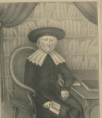

*Lithograph of Rav Asher Leib Ginzburg-Wallerstein by Frederic-Emile Simon of Strausbpirg, circa 1820.*

R' Asher was born in 1754, in the old age of his father, the Sha'agas Aryeh (one of the greatest Torah scholars of the 18th century). R' Asher was a student of his father and of R' Meir Zayeh of Metz, and later served as rabbi of Karlsruhe.

R' Gedaliah Rothenburg of Bodingheim, a student of the Sha'agat Aryeh and of R' Asher, writes of the latter (in his approbation to the former's Talmud commentary, Gevurat Ari): The son is a limb of his father . . . and is a famous rabbi known throughout the diaspora. . . As a youngster, seven or eight years old, he already had a sharp and well-honed mind. At that age, if he was shown a difficult passage by Rambam and was told in what part of the gemara the answer lay, he could work out the answer in a short time.

“When he became bar mitzvah, his father said to him, "Because I know that you have a clear mind and that you are a vessel which is fit to receive the Torah of Hashem, therefore be strong and become a person who is great in Torah - "A wise son pleases his father" [in the words of Mishlei 10:1] - then I will be honored because of you in the world of Truth."

When he was 15 years old, he studied with his father an entire tractate every day . . . When he was 17 or 18, the rabbinical court and the Torah scholars of Metz and all the travelers who passed through Metz were amazed by his sharpness and vast knowledge, and his father publicly declared that his son was sharper than he.

The best-known student of R' Asher was R' Yaakov Ettlinger, author of the popular Talmud commentary, Aruch La'Ner, and teacher of R' Samson Raphael Hirsch. R' Ettlinger attributed to R' Asher the most powerful influence on his way of learning. Some of R' Asher's Talmudic interpretations are printed in Sheilos U'teshuvos Sha'agas Aryeh Hachaddashos and in R' Ettlinger's Binyan Zion. R' Asher died in 1837. (Gedolei Hadoros ; Rabbi Samson Raphael Hirsch [Artscroll])

*Reprinted from the Parshat Chukat 5785 email of R’ Yedidye Hirtenfeld’s whY I Matter parsha sheet for the Young Israel of Midwood in Brooklyn.*

**The Helicopter Crash**

**that Saved a Kibbutz**

**By Sarah Pachter**

*On October 7, IDF commander Shraga R. survived a helicopter crash under fire—unknowingly diverting terrorists and saving a kibbutz in a chilling twist of fate.*

On October 7th, Shraga R., a 22-year-old IDF commander, was asleep on base at Nevi Musa, located between Jerusalem and the Dead Sea. It was Shabbat morning.

At 6:00 AM, one of Shraga’s friends walked in, screaming, “There are rockets!”

Everyone rolled over, exhausted. Shraga grumbled, “Dude can you please leave? We went to sleep three hours ago.”

At 7:00 AM, an officer ran in and pulled Shraga aside. “Get the guys ready—there has been a terrorist attack. We need to leave ASAP.”

“Nobody knew the full scale yet,” Shraga explained in an Aish.com interview, but some soldiers had turned their phones on and saw a few videos in Sderot. They saw that there were terrorists on the ground. People were dead, and they needed backup.”

Shraga woke the soldiers up and got them into formation. They had no grenades, or anything heavy—just bullets.

Buses were supposed to arrive at 9:15 but a decision was made that it was too dangerous to dispatch them. At this point, the soldiers were skeptical and assumed the buses not showing up was part of a drill. Shraga explained, “Tons of soldiers said, ‘Oh, this isn’t real. This is how they are starting our training stimulator.’”

A higher-up commander called a friend in the Air Force, asking for transportation. “Within the hour, they arranged for a helicopter to come in.”

Before taking off, the soldiers were told to hand in their phones. The IDF didn’t want anyone being tracked or posting on social media. Shraga began texting his family before leaving the base, but erased it because he didn’t want to scare them unnecessarily.

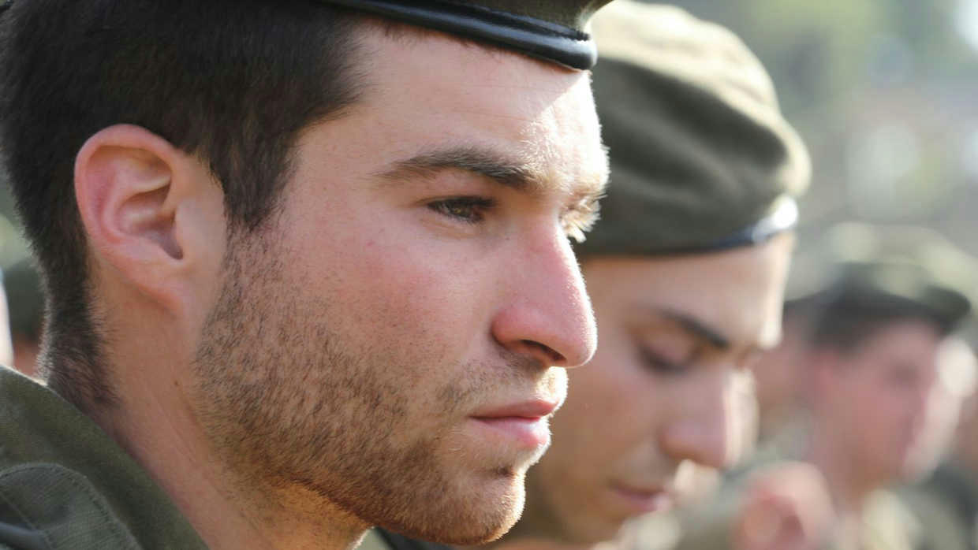

**The Helicopter Pilot was Nervous**

They headed toward the helicopters, piling 60 soldiers into the chopper which could fit about 40 soldiers comfortably. The pilot was nervous and wasn’t sure they could even take off.

Soldiers asked, “Can we get commands? Instructions?” But no one knew anything yet. They were one of the first big forces headed to the area and were told, “We don’t have information to give you. We just know it’s bad.”

Shraga sat toward the back of the helicopter near the window. The helicopter flew low and the pilot was looking for somewhere safe to land. Shraga saw smoke, small fires, and guys on motorcycles racing around. Then, out of nowhere, they heard a machine gun. It pierced through the helicopter.

“Our helicopter’s gas tank got hit by an RPG. I look behind us, and see the pilot dropping our fuel tanks so we wouldn’t explode.”

The helicopter shut off and started falling quickly. “With only a little bit of gas left, the pilot was able to crash-land the helicopter. We slammed into the ground and bounced a few times like a ping-pong ball.”

The pilot tried opening the back door but it wouldn’t budge because the hydraulics were down. Smoke was building up inside. They were all trapped and it was just a matter of time before it exploded.

**Nowhere to Take Cover**

“Guys started climbing out of the front of the helicopter. Finally, the pilot was able to manually open the back. We climbed out and were getting shot at. We were in the middle of the field with nowhere to take cover. There was no high or low ground, no trees, and the bullets were flying towards us.”

Shraga and another commander began running and returning fire to gain cover. Then Shraga suddenly then realized that he wasn’t near his combat buddy.

“Everyone in the combat unit has a buddy. You don’t leave each other’s side, 24/7, especially during war. You even go to the bathroom together.”

Shraga didn’t see him anywhere. He realized he was still stuck in the helicopter. Over radio, he told an officer to go check the helicopter. Sure enough, Shraga’s buddy was stuck inside because one of the cables of the helicopter was latched onto his bag. The officer unhooked him and he climbed out. Thirty seconds later another RPG hit the helicopter and it exploded.

**No One Was Killed in the Explosion**

Everyone made it out in time. No one was killed in the explosion.

They later found out that their crash managed to save an entire kibbutz.

The helicopter crashed between Kibbutz Be’eri and Alumim. Because they landed there, a group of terrorists got scared and ran away- never entering Kibbutz Alumim. Shraga explained, “My cousin actually lives in that kibbutz. She called his parents and said, ‘A helicopter landed right in front of our kibbutz and scared the terrorists away.’”

His dad proudly shared, “That was my son.”

After escaping the crash and explosion, the unit needed to deal with the danger of being in an open field. “Heavy fire is another way of getting cover. You move like a centipede, each group dropping and rising. It gives you a few seconds to start running and moving. Then you drop again and shoot again.”

**Nothing Prepares You for the Real Thing**

The soldiers had never faced combat before and reacted very differently. Some soldiers were shooting back. Others were frozen with fear. The officers were giving orders, trying to keep people grounded. “Even if you go through combat training, nothing prepares you for the real thing.”

Shraga stayed calm. “I didn’t have time to process. You just have to make sure they’re safe. And if they get hurt, you help them.”

At this point, they realized their enemy was Hamas because their guns make a distinct sound.

The soldiers moved to a small wooded area, about 200 meters from the crash, and regrouped. The officer was on the phone, coordinating next steps.

Just then, a second helicopter landed behind theirs. It picked up the wounded and the pilot, and dropped off another 60 soldiers.

The soldiers began running toward Kibbutz Be’eri. “It was the longest run of my life.” Shraga said. He grabbed an injured soldier’s machine gun and started running with it. Even though he had to carry additional weight, it gave him more firepower than normal.

The soldiers had no idea what they were about to walk into. As they got closer, they passed burnt corpses and melted cars. The scene was much worse than they expected.

They saw many police officers standing around outside the kibbutz. Shraga asked, “Why aren’t you going in?”

“We don’t have enough manpower. Our commander told us to stay out here and help with rescues.”

Shraga gave a policewoman his name and number. “If anything happens, tell my parents I love them.” He didn’t know if he’d make it out.

They moved in formation, looking for other soldiers to try to get a clearer picture of what was going on. They saw a fellow soldier in army gear. Shraga’s officer yelled, “Are you okay?” But when the soldier turned to face them, they realized he was actually a terrorist holding different weaponry. They took him out. Realizing that Hamas terrorists were dressed as IDF soldiers made everything more complicated.

**What They Saw Was Horrific**

Shraga and his unit moved methodically, house by house. What they saw was horrific, some of which remains classified. Entire families killed in safe rooms. Women violated; children murdered.

They cleared the kibbutz for hours, pulling out families that were still alive. It took a long time because many were too scared to open the doors and let the IDF in.

Shraga found a couple with their young son who was scared and hungry. He offered him his sour sticks but the boy refused. Shraga joked with the parents, “I've never seen a kid refuse a sour stick!”

But at that moment, Shraga understood that these families didn't need food or water, they just needed to feel safe.

**A Narrow Escape**

While fighting in the Kibbutz, Shraga was in a firefight and taking cover behind a wall.

He happened to look left, through a gate, and saw a terrorist ten feet away, pointing a gun at his head. The terrorist smiled, then pulled the trigger.

Shraga described that moment, “Everything just slowed down. You know the moment you know you are going to die, how your whole life runs through your mind? Everything you did. Were you a good person or a bad person? Did you do enough?”

The bullet hit the gate and missed him completely.

Shraga had many other close calls. Grenades were repeatedly thrown at him. Shraga tried to kick them away but more kept coming. Miraculously the grenade he couldn't kick away in time never exploded. “Big miracles,” Shraga recognized. “It definitely makes you think about the fact that there’s a God looking out for you.”

It took the units three full days to clear Kibbutz Be’eri. Every few minutes, another terrorist would pop out of hiding as if in a video game. They slept in 20-minute rotations, with an hour on guard duty. There was barely any food.

Shraga noted, “These terrorists are all on drugs. Many had tourniquets already on their limbs, ready to treat themselves in order to keep fighting.”

Gaza

Since October 7th, Shraga has been fighting in Gaza, uncovering tunnels.

“I was part of an operation where we discovered a tunnel, and we had Special Forces come in and explore…they found bodies of hostages.”

Shraga, who was born in Passaic, New Jersey, is happy that his parents made the decision to move to Israel and wouldn’t have it any other way.

“Growing up in Israel is an amazing experience. I have no regrets… Going to the army was a time for me to put all my things aside and give back to a bigger cause.”

Reprinted from the current website of aish.com